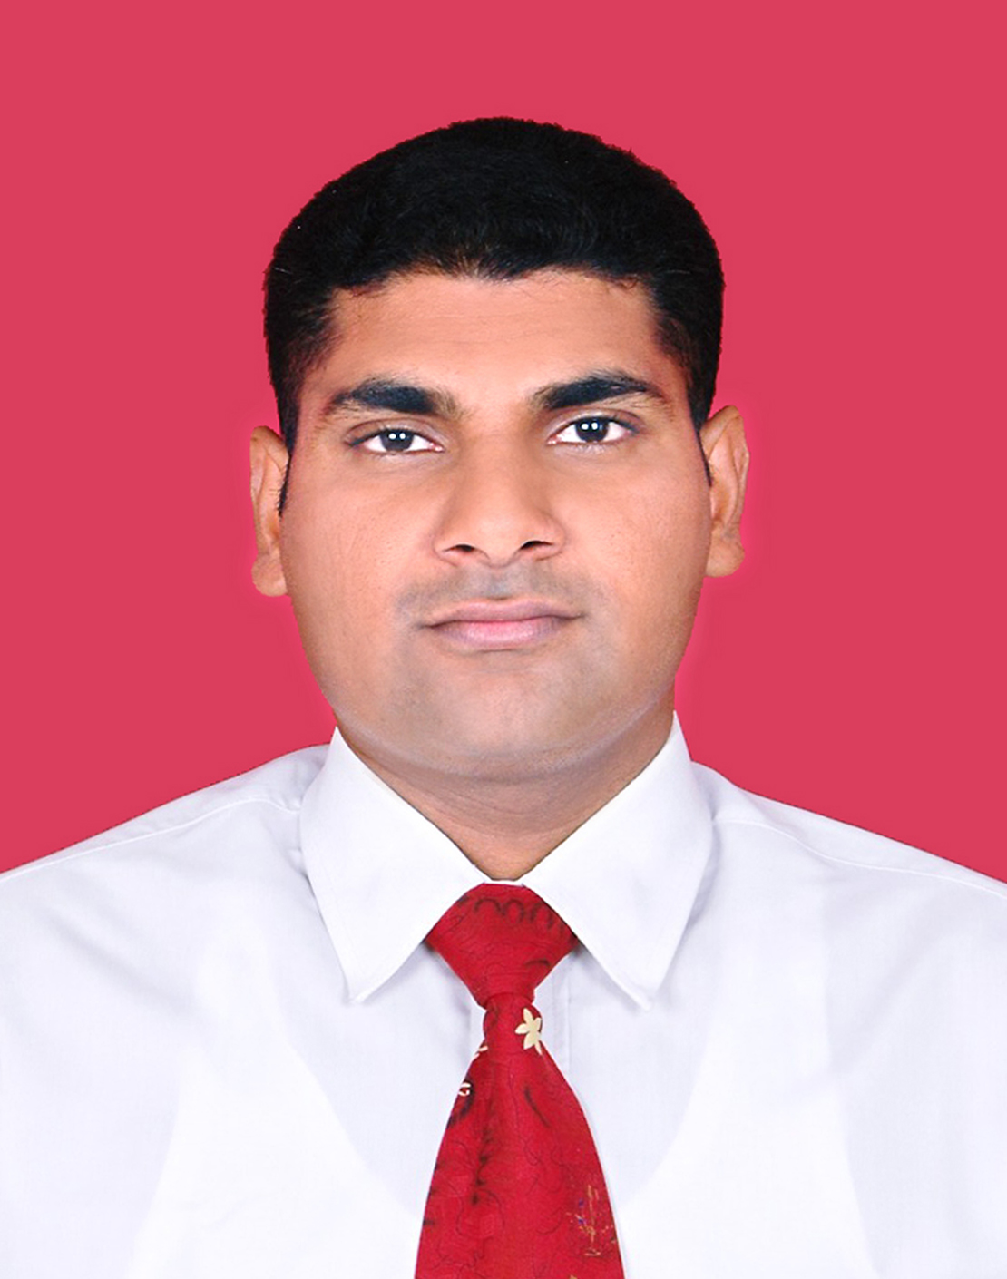
CURRICULUM VITAE

A.R.M.FEROZE
No.61 Main Street, Panwila,
Kandy,
Sri Lanka.
E mail – feroze_ur2007@yahoo.com
0094728384657

CAREER OBJECTIVES
To obtain a responsible and challenging position in a successful establishment to expand my skills and knowledge for personal and professional growth.

POST APPLIED FOR ANY SUTTABLE POSTION
04 years working experience in U.A.E. as Barman cashier & front office receptionist

EDUCATIONAL QUALIFICATION

G.C.E. (O/L) 1993 INDEX NO 3916250
Islam Distinction
Tamil language & Li Credit
Second language (Sinhala) Credit
Maths Ordinary
History & Social Studies Ordinary
Commerce & Accounts Ordinary

G.C.E. (A/L) 1996 INDEX NO.231183

Islam Distinction
Economics Ordinary
Islamic Civil Ordinary
Geography Ordinary

G.C.E. (O/L) 2001 INDEX NO 13832581
English Credit
Second language (Sinhala) Credit

G.A.Q.(B.A)FIRST YEAR EXAMINATION
Islamic Civil Ordinary
Geography Ordinary

PROFESSIONAL QUALIFICATION

A. Diploma in Graphic Designing

Contact by : Sri Lak Computer Academy
No.76, Main Street Panwila, Kandy.

B. Diploma in Information Technology

Contact by : Sri Lak Computer Academy
No.76, Main Street Panwila, Kandy.

B. Diploma in Visual Basic Programming

Contact by : Sri Lak Computer Academy
No.76, Main Street Panwila, Kandy.

Employment Records

3. Perfect Digital & Imaging Service (Pvt) Ltd.
No.23, Yatinuwara Veediya , Kandy.

Position : Graphic Designer
From 2001 – 2002

4. Zakher Hotel Abu Dhabi U.A.E.

Position : Barman & Cashier F&B Department
From 2003 – 2007

EXTRA ACTIVITIES

a) I participated Cricket, college band group and perfect board.

PERSONAL DETAILS.

Nationality - Sri Lankan

Sex - Male

Date of Birth - 13/06/1976

Marital Status - Married

Passport No - N 2797407

Date of Expiry - 22/03/2021

I hereby Declare that all information provided above are true and correct to the best of my knowledge.

Abdul Razak Mohamed Feroze

